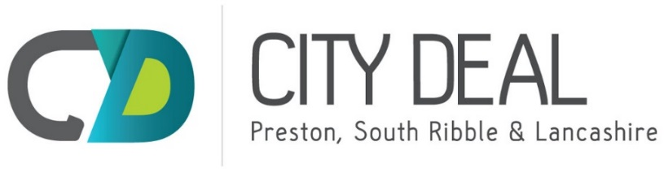

**POSITION OF THE MODEL AS AT 31st December 2017**

* Surplus over 10 year deal ( 15 yr collection period) is  **£3.675m.**
* Changes since last model
  1. Inclusion of Mitigation adjustment line following approval to fund NWPRP (£75.150m ) as this will be required in time for FBC approval in 18/19 to allow the model to stay within agreed funding limits
  2. Section 106 monies received more than forecast (£0.243m)
  3. Increase in loan interest payable to HCA following revised BDP (-£0.024m)
  4. Increase in other expenditure lines (-£0.22m)
  5. Reprofiling of expenditure lines to latest forecast spend - no overall impact but changes to cash flow position over years.

**Finance Dashboard - Quarter 3 Oct-Dec 2017 Appendix B**

This summary provides an overview of how the City Deal Programme IDF has performed during quarter 3 – October to December 2017

Split of total income in the model showing received, secured and still unsecured

The graphs below show the position **over the life of the deal** as at Qtr 3 year 4.



Split of Total Expenditure split by spent, committed and allocated but not yet committed



The above position shows the assumption that the commitment to North West Preston roads programme will be met by mitigating actions. As at qtr 3 year 4 the deal has received or secured 60% of the income forecast and spent or committed 67% of the expenditure forecast over the life of the deal.

**KEY RISKS**

* The agreement to fund NWPRP to total of £189.45m has created the need for mitigation measures to ensure the model remains in balance, these can be increased income from new sources or sites or reduction in existing expenditure allocations or a combination of both, until this mitigation is agreed there remains a risk of **£75.150** to the model.
* Viability of sites – Partners are committed to maximising the value of developer contributions per site – this is constrained by the commercial viability.
* Delays to housing developments – the City Deal IDF is over a 10 year period with 5 year run on to collect monies – housing delays past year 10 could negatively impact the model and funds available to spend.
* Changes to government Policy affecting income levels to the model. Currently NHB changes announced with further announcements expected on CIL and Business rates retention.
* Infrastructure budget allocations and cost estimates when schemes come forward for approval may differ, this needs managing within the programme to ensure the model remains in balance.

CIL contributions based on current forecasts secured by district based on housing return data

